PROBLEM STATEMENT:

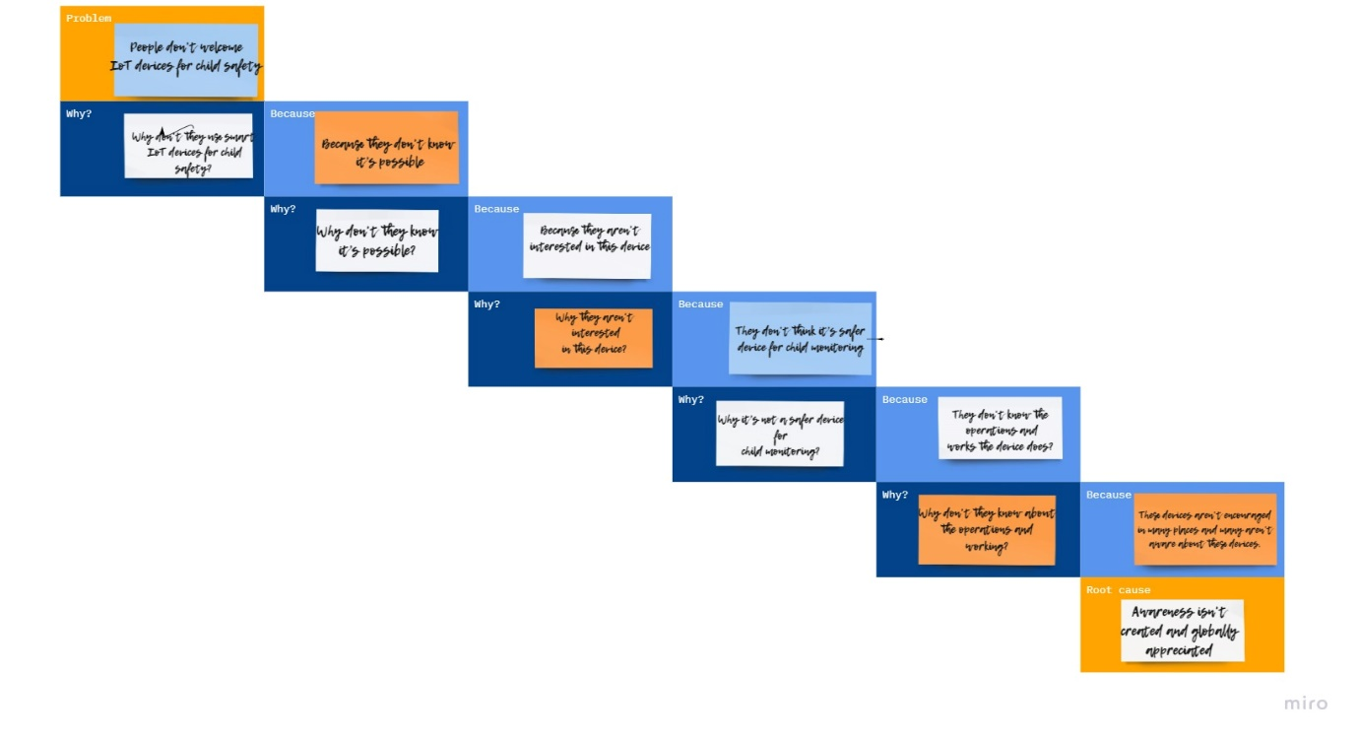

TEAM ID: PNT2022TMID37747

TEAM BATCH NO: B6-6M2E

TEAM MENTOR: A

TEAM LEADER: N.PRIYADHARSHINI

TEAM MEMBERS: P.DURGA

P.JANANI

E.PRABADEVI

TEAM SIZE: 4